# Package priority algorithm

Weilin Lu

# Assignment 3 1/31/2023

## 1 SUMMARY DESCRIPTION—UPDATED

For this project, I want to do a classification based on the destination of the package, and classify them according to the city, state and country where the package is located. So the first choice is not to seek their common ground. This part can be done using divide and conquer. We will talk about the international classification of the package according to the city classification of the package.

In this assignment, based on the automatic classification of packages in the previous assignment, I arranged a priority for each package, and then told the user the priority of package delivery. The method I use is the merge sort algorithm.The first data in the csv file is the package number, the second data is the state, the third data is the city, and the last data is the priority. Finally, you need to inform the user of the delivery order of the package.

## 2 I/O EXAMPLE FROM PROJECTED COMPLETED PROJECT—UPDATED

Input CSV file:

1, MA, Boston, 1

2, CA, Los Angles, 2

3, MA, Worcester, 3

4, MA, Boston, 4

5, CA, San Francisco, 5

6, CA, San Diago, 7

7, CA, San Diago, 6

OUTPUT:

MA:

Boston: Package #1, Package #4

Worcester: Package #3

CA:

Los Angles: Package #2

San Francisco: Package #5

San Diago: Package #6, Package #7

Delivery Order: #1, #2, #3, #4, #5,#7,#6

## 3 REQUIREMENTS IMPLEMENTED IN THIS RELEASE

### 3.1 Input requirement

### Input should contain package number,state,.city and priority.And in the imput form should looks like the test data I provide above.

### 3.2 Output requirement

Output should contain group the package by state,then by city. And also the output should contain the delivery order.

## 4 ILLUSTRATIVE OUTPUT

## 

## 5 YOUR DIRECTORY

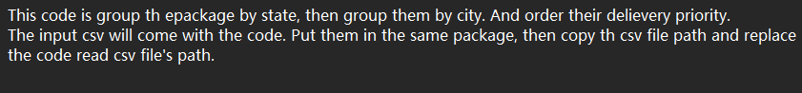



## 6 SPECIALIZED SORTING IMPLEMENTED

The time efficiency of the merge sort algorithm implemented of my code is O(nlogn), where n is the number of packages. Merge sort is a divide-and-conquer algorithm.It divides the input into smaller subproblems and solves them recursively. Merging two sorted subarrays takes O(n) time, and the overall time complexity of merge sort is O(nlogn), since the size of the subproblem to be solved is halved in each iteration.

### 6.1 Class model and Sequence Diagram

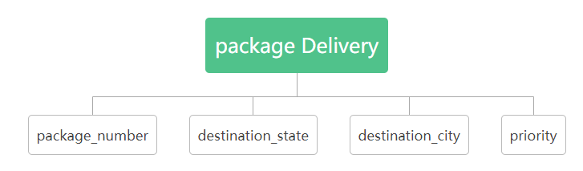

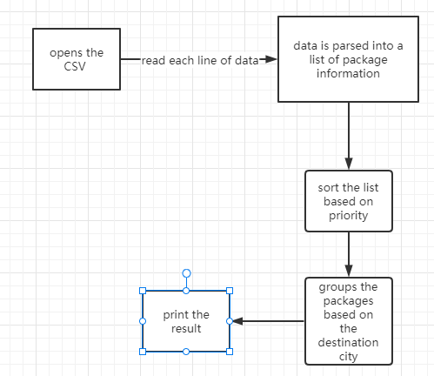

### 6.2 Code showing sorting.

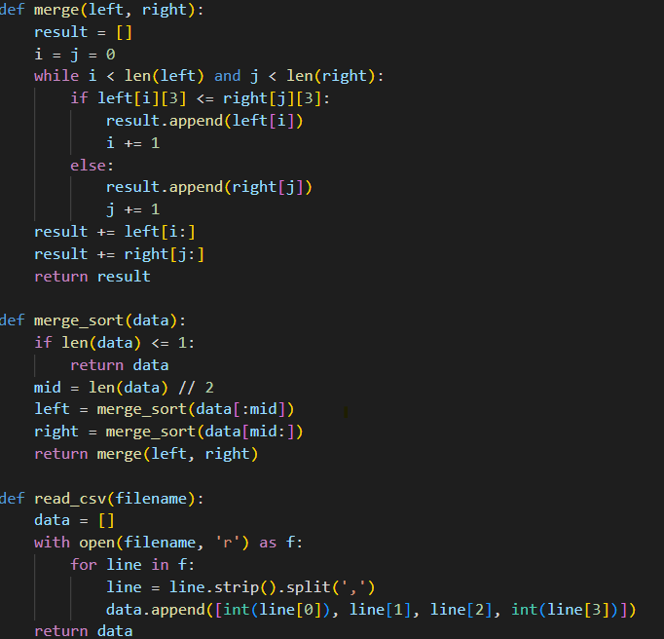

In my project,the code uses the merge sort algorithm to sort the packages based on their priority. This allows for a fast and efficient delivery process, as packages with higher priority are delivered first, and packages with lower priority are delivered last.

## 7 YOUR CODE

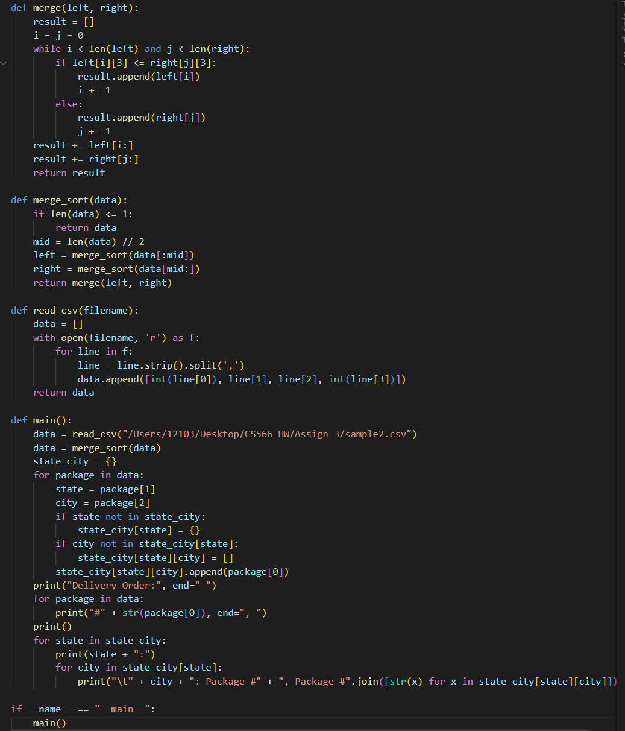

## 8 Evaluation



## References (if used. Each of [1], [2], etc. should occur within the paper above.)

[1]

[2]

## Appendix 1 (if needed; should be referenced above, and will be read as-needed only)

## Appendix 2 (if needed; should be referenced above, and will be read as-needed only)